Spine Education and Research Foundation
Activities Report of Operation Straight Spine
Ramakrishna Mission Hospital, Kolkata, India January 21- February 04, 2017
Jeff McConnell, MD
This Activities Report includes a description and pictures of the surgeries performed on patients with a variety of spinal maladies

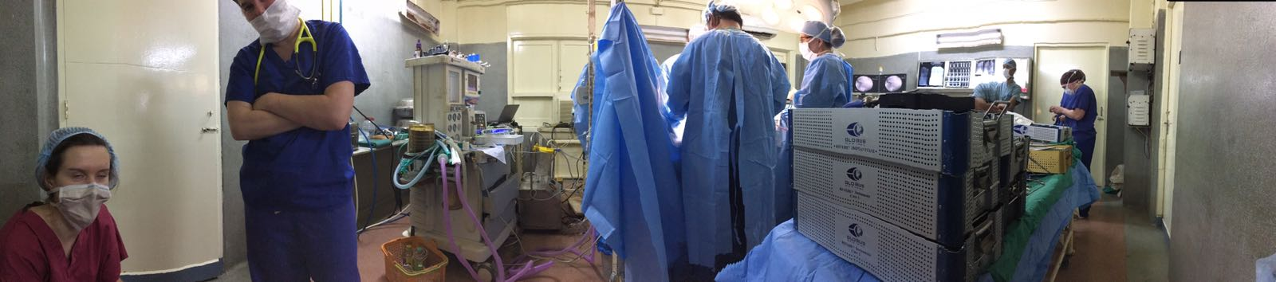

Team Members for OSS 2017:

INDIA: Ujjwal K Debnath, FRCS – Orthopaedic Spine Surgeon
UK: Neena Seth – Consultant Anaesthesia
Meera Alexander – Consultant Anaesthesia
Priya Krishnan - Consultant Anaesthesia
Lucy Dancy - Consultant Anaesthesia
Kerry Mulqueen – Scrub Nurse
Bethan Salmon, RN – Paediatric Nurse Specialist
Rachel Imber, RN – Anaesthetic Nurse Specialist
US: Jeff McConnell, MD – Orthopaedic Spine Surgeon
Denise Lawyer, RN – Neuroscience Scrub Nurse
Johanna Ziegler, CST – OR Scrub Tech
Mickhail Frenkel – Neuromonitoring Specialist
Christian Kuntz - Globus Medical Representative
Sajili Bacallo – Globus Medical Representative
Collin McConnell – Shippensburg University student volunteer

Sponsors:
We would like to acknowledge our sponsors who generously donated to support Operation Straight Spine 2017.

Thank You!…..

Globus Medical Inc.

Emirates Airlines Foundation

Implanet

Through These Hands Foundation

Spineguard

Fronheiser Family Foundation

Nuvasive Spine Foundation

Spine Education and Research Foundation

Laboni Choudhury, MD

St. Lukes Hospital and Health Network

Surgery Center of Allentown

SPIRIT India, Kolkata

Guys Hospital, London

Lehigh Valley Hospital and Health Network

21 JAN 2017
US team consisting of Jeff McConnell, MD, Collin McConnell, Johanna Zeigler, CST, Mickhail Frankel, Denise Lawyer, RN, and Christian Kuntz arrive in Kolkata from New York (via Dubai, UAE) on Emirates Airlines at 18:15. The team is met by one of the orthopaedic registrars and a driver from the Ramakrishna Mission Hospital. The transport van is filled to the brim with our multiple boxes of medical supplies and luggage as we are transported to the Tollygunge Club where the team will stay for the coming two weeks.
At the Tollygunge Club we are met by Neena Seth, Meera Alexander, Rachel Imber and Bethan Salmon who had arrived from London, UK the day before. We discuss the plans for the coming week.
22 JAN 2017
Ramakrishna Mission Hospital: The first day is spent unpacking our supplies that we brought with us from the US/UK and organizing the store room. Along with Anaesthetists, Neena Seth and Meera Alexander, we make rounds on the various wards to assess the patients who are admitted for surgery over the next two weeks. Patients included adolescent children with idiopathic and congenital scoliosis and an 18-month old baby with congenital scoliosis. We also evaluate three adults with spinal stenosis and spondylolisthesis. We choose one of the adult patients for the first day of surgery and relate the equipment needs to Mr. Kuntz, our Globus Medical equipment representative, so he can have the appropriate implants/instruments sterilized for the first day.
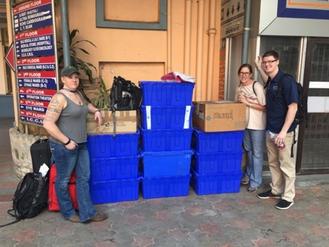
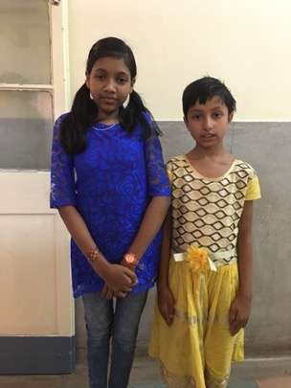
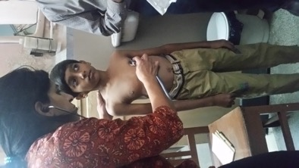
Later that afternoon we conducted a brief clinic where we evaluated a number of the patients that had surgery last year during OSS 2016. All the patients were doing well. Everyone is exhausted from jet-lag so we return to the Tollygunge club so that we can be well rested for the first day or surgeries.
Pre-op evaluation
Priti Karar, age 13 and Tithi Pan, age 10. Follow-up patients from OSS 2016
Unloading and sorting supplies
Aman Kumar, age 13, follow-up patient from OSS 2016
Pradip Das, age 15, follow-up patient from OSS 2016.
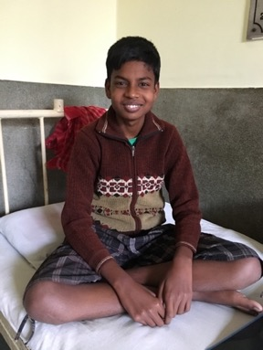
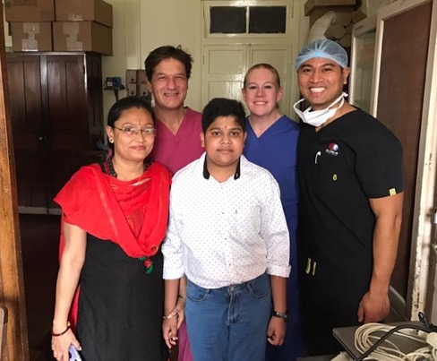

23 JAN 2017
First Day of surgery at RKMSP.
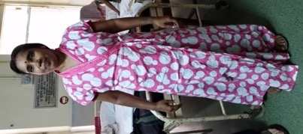
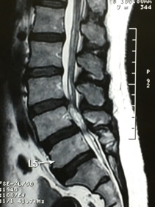
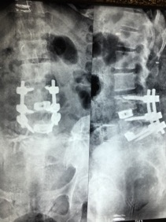
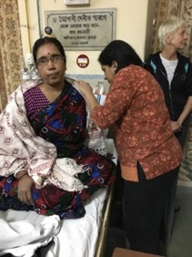
Lata Shil, 40 yo female with severe spinal stenosis L4-5, degenerative spondylolisthesis at L4-5 and a herniated disc and stenosis at L3-4. She had severe back and leg pain and was very limited in her ability to stand or walk for any length of time. Surgery consisted of decompression of the severe stenosis, excision of the herniated disc, transforaminal lumbar interbody fusion at both L3-4 and L4-5 using local bone graft, placement of Sustain titanium cages and pedicle screw instrumentation from L3 through L5.

The team returned to the Tollygunge Club around 18:30 and had dinner at the club around 8:00.
24 JAN 2017
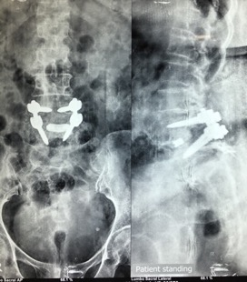
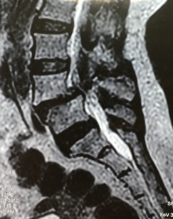
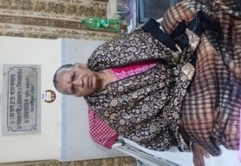
- Kamala Baidya, 63 yo female. Kamala was barely able to walk and had extreme pain in her back and legs due to severe foraminal stenosis associated with an L4-5 spondylolisthesis. Surgery consisted of a thorough decompression, complete discectomy and placement of a Sustain titanium TLIF cage between L4-5. Bone from the decompression was used for bone grafting and the spondylolisthesis was stabilized with screws and rods.

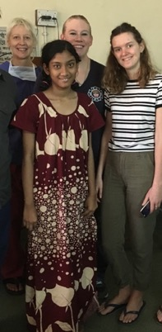
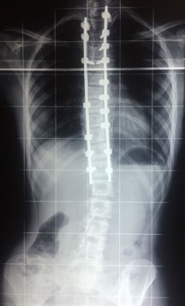
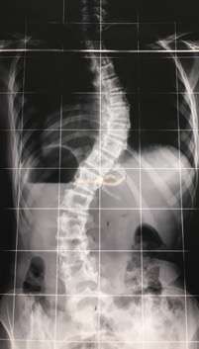
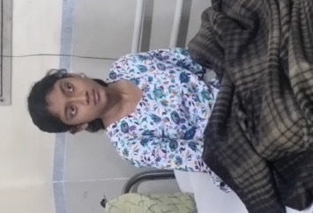
- Deepsikha Saha, 13 yo female. This patient had a Lenke 1C adolescent idiopathic scoliosis deformity measuring 45 degrees. Surgery consisted of a posterior approach with curve correction and instrumented spinal fusion from T2 to T12. Due to her small frame we used the the 4.5mm implant set. For the first time we also utilized the “Jazz Band” sublaminar band system from Implanet. These bands are placed around the apex of the scoliosis curvature and allow the gradual translation or reduction of the curvature to the spinal rods. They are stronger than sublaminar hooks and are safer to use than pedicle screws in thoracic spine. Excellent correction of the curvature was achieved. Deepshika spent two days in ICU post-operatively and her course was unremarkable. By the third day after surgery she was fully ambulatory and very happy with her surgical result.

We started our day very late and it was not until 10:00 pm before we returned to the Tollygunge club. We had Chinese take-out food for a late dinner.

- JAN 2017
Shruti Sharma, 11 yo female. Shruti was diagnosed with Prader-Willy syndrome which consists of obesity, diabetes mellitis, and developmental delay. She had presented to us in 2016 for consideration of correcting her thoracic scoliosis however her diabetes was newly diagnosed and her blood sugars were poorly controlled. Therefore, we thought it best to delay her surgery until this year so that her diabetes could be brought under better control. Shruti was certainly one of our most challenging cases this year, not only from a medical management standpoint but also by the magnitude of her spinal deformity. By 2017 her left thoracic scoliosis curvature had progressed to 92 degrees. We did not start Shruti’s surgery for several hours after she was placed under anaesthesia due to unexplained blood collecting in her right lung. The bleeding eventually stopped and she was stable enough to complete the procedure. Surgery consisted of posterior correction of the scoliosis and instrumented fusion from T2 to L3 using the 4.5mm implant system. We again utilized the Jazz Band sublaminar band system to aid in correcting the apex of the curve.
By the time we finished Shruti’s surgery and got her stabilized in the ICU it was very late in the evening. We again had take-out food for dinner.
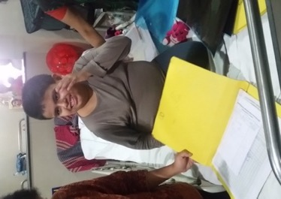
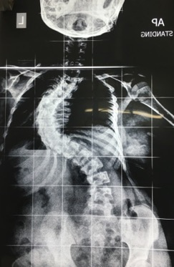
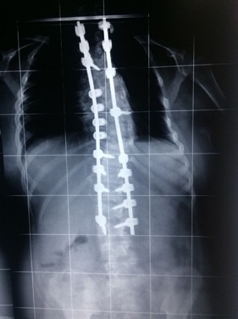
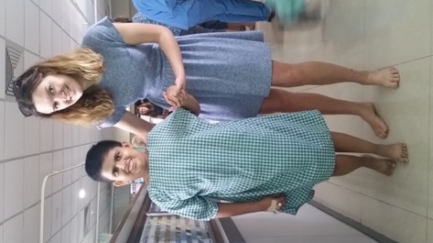
Shruti’s post-operative course was somewhat stormy. She remained intubated in the ICU for the first 24 hours. Her blood pressure was labile and she ran high temperatures. On post-op day #1 the breathing tube was removed successfully but her right lung had filled with fluid and she required aggressive manual pulmonary therapy to help clear the lung. Ultimately, Shruti did very well and by the 4th post-op day she was smiling, walking and coloring pictures in her book.

26 JAN 2017
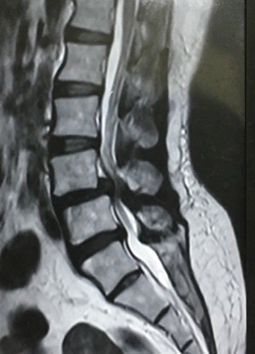
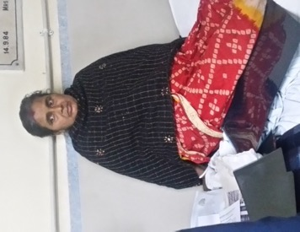
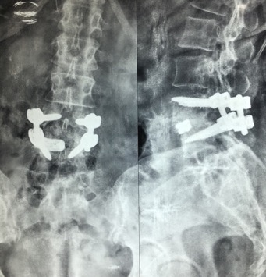
Mamata Biswas, 40 y.o. female. Thursday was a bank holiday in India and normally the operating theatre would have been closed. The head sister and a small number of RKMSP OR staff agreed to let us operate. Mamata was suffering from right greater than left leg pain and back associated with a herniated disc, spinal stenosis and and a degenerative spondylolisthesis at L4-5. Surgery consisted of decompression of the spinal stenosis, discectomy, placement of Sustain titanium cage and local bone graft between the vertebrae followed by pedicle screw and rod stabilization of L4-5.

27 JAN 2017
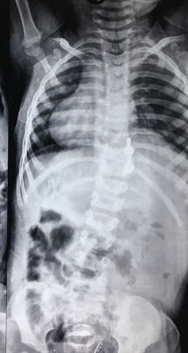
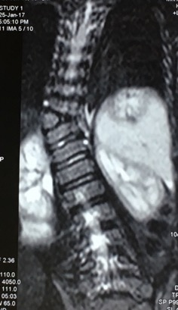
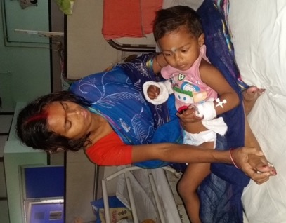
- Arannya Adhakary, 18 month old male. This young baby had a congenital scoliosis associated with a T11 hemivertebra. This type of congenital defect has a very high propensity to progress to a severe deformity as the child grows. This condition is best treated early by removing the abnormal vertebra and fusing the growth plates at that level. Surgery consisted of removal of the T11 hemivertebra, correction of the local kyphosis and scoliosis, and limited fusion from T10 to T12 with instrumentation using the Protex-C 3.5mm rod and screw system.

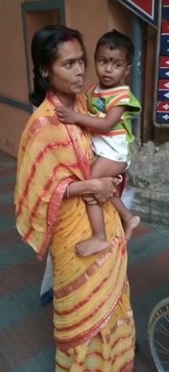
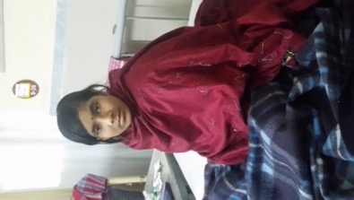
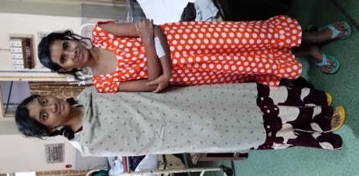
- Puja Adak, 13 yo female. Puja had severe thoracolumbar congenital kyphoscoliosis associated with a T12 hemivertebra. Surgery consisted of placement of rod construct from T10 to L2 with screws at T10, T1, L1 and L2 on the right and T10 and L2 on the left. The hemivertebrae at T12 was excised completely and the defect filled with a 7mm Sustain titanium cage and packed with local bone graft fro fusion. Rods were used to correct the deformity and stabilize the spine. Excellent correction was achieved.
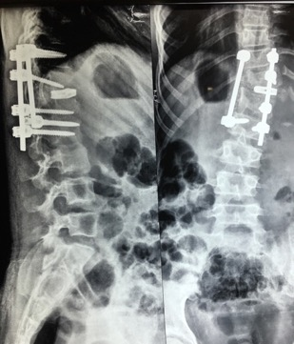
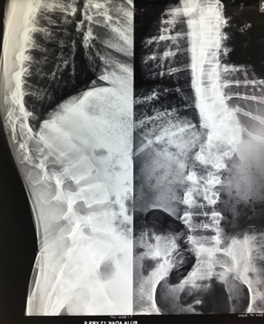
28,29 JAN 2017
No Surgery
30 JAN 2017
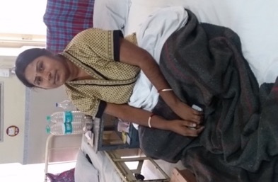
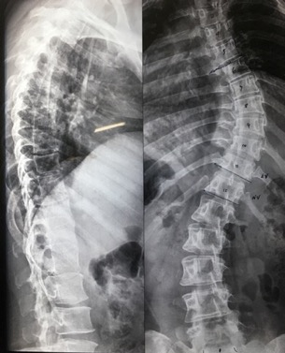
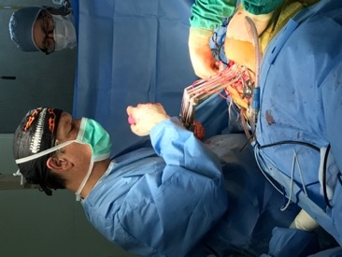
Sampa Chakraborty, 35 yo female. This patient had untreated adolescent idiopathic scoliosis and her curvature had advanced to 55 degrees. She was experiencing pain in the thoracic spine in the region of the spinal curvature. Surgery consisted of posterior instrumented fusion and correction of the scoliosis from T2 to T12. We utilized dual rods with hook and screw foundations. Ponte osteotomies and Five Jazz Band sublaminar bands were used to help reduce the apex of the curvature from T5 to T10 where the most severe part of the deformity was located
The second group of anaesthestists, Lucy Dancy and Priya Krishnan arrive from London.
31 JAN 2017
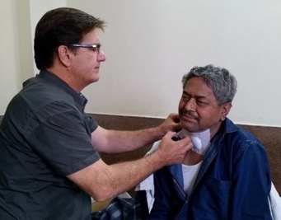
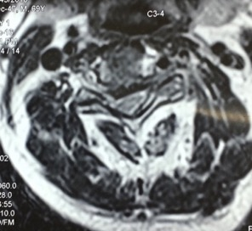
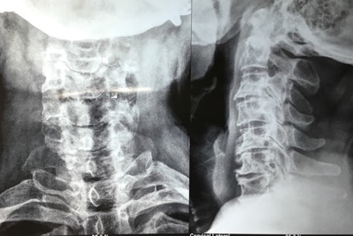
Sisir Chakraborty, 69 yo male. This man had cervical degenerative disc disease. He had developed myelopathy with weakness in the hands and difficulty walking. MRI scan of his neck showed severe stenosis with spinal cord compression at C3-4 associated also with a herniated disc. Surgery consisted of anterior C3-4 discectomy and decompression of the spinal cord followed by interbody fusion, placement of a 5mm PEEK cage and 23mm anterior locking plate with screws from C3-C4. One small incident occurred when his bite block dislodged from his mouth and he bit his tongue causing a 1.5cm laceration on the bottom of the tongue. We repaired the laceration using 3.0 chromic gut suture.

UK team members Neena Seth, Meera Alexander and Rachel Imber depart for London.
01 FEB 2017
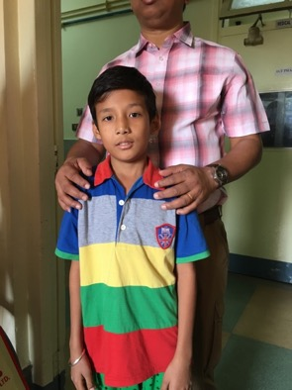
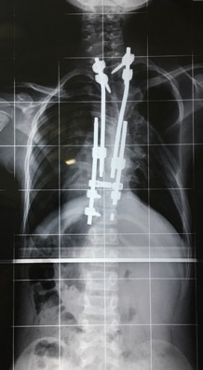
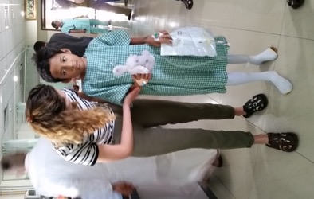
Neil Lama, 11 yo male. Neil is one of our veteran patients who first operated on 5-6 years ago. He had a congenital scoliosis in the thoracic spine secondary to multiple abnormalities including fused ribs on the right side. His first operation consisted of a procedure to release his tethered cord at the L5-S1 level. This was followed by resection of a hemivertebra and placement of a growing rod construct. Subsequent operations consisted of a growing rod lengthening procedure, revision of hardware and additional lengthening. On this occasion we removed most of the previously placed hardware, fused the remaining levels of the thoracic curve and replaced one rod on the left side to provide some stability. This should be the last procedure needed for Neil.
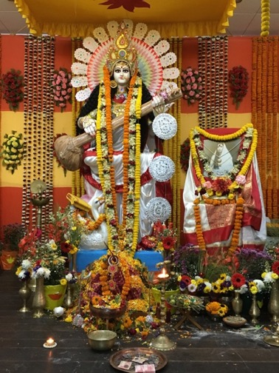
We only did one case this day because of the Puja, a religious holiday, celebrating Saraswati, the goddess of knowledge. The head sister from the Operating Theatre, Bela, invited all of us to a wonderful lunch as part of the celebration.

02 FEB 2017
- Anju Jha. 41yo woman with a lytic L5-S1 spondylolisthesis, grade 1, with right greater than left foraminal stenosis and L5 nerve root mediated leg pain. She could not stand or walk for any meaningful time or distance. Her problem was complicated by the fact that she had an L3 congenital hemivertebra producing a localized scoliosis and loss of normal lumbar lordosis. It would have been too complex and risky to try to correct the hemivertebra deformity so our goal was to relieve her primary issue of leg pain and low back pain due to the problem at L5-S1. Surgery consisted of a transforaminal lumbar interbody fusion (TLIF). Her anatomy at the L5-S1 junction was challenging due to the angle ot the S1 endplate tilted toward the right. She also had a very small L5 pedicle on the right. We first inserted all the pedicle screws. The L5 screw had to be inserted through a separate incision to be able to have the necessary trajectory to place the screw accurately into the pedicle. The loose L5 lamina was removed and then morselized to use as bone graft. The Right L5 nerve was decompressed within the foramen and the disc removed vompletely. An 11mm Sustain titanium cage was placed well anterior in the disc space to allow for good lordosis at L5-S1. Bone graft was placed between the vertebrae and two rods placed to secure the construct.
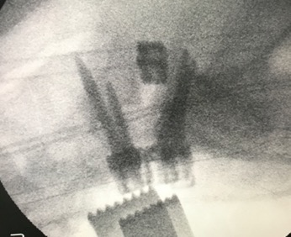
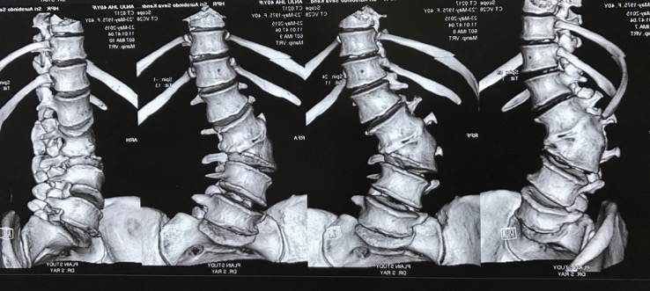

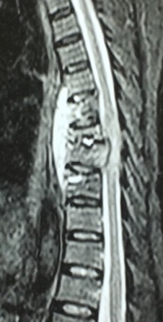
- Sumita Khanra, 46 yo woman with tuberculosis of the spine involving T9, T8, T7 and T6 vertebrae with resulting kyphotic deformity and a large paraspinal abcess which was compressing the spinal cord. She had been treated with triple antibiotic therapy and a spinal brace. Unfortunately the TB appeared to be resistant to drug therapy. She was essentially bed/wheelchair bound, her legs too weak to allow her to walk. She had back pain as well. We debated about how aggressive an operation should be – anterior/posterior or just a posterior approach alone. We approached the spine from the back and inserted pedicle screws from T3 to T5 and T10 to T12 bilaterally. We then performed a costotransversectomy on the left at T7 with hemilaminectomy of T7,T8 to drain a large amount of the TB abcess and decompress the spinal cord. We then corrected the local kyphosis by placing two rods from T3 to T12. A posterior fusion was then preformed using local bone and a large kit of RhBMP2 graft.
